Newsletter
Volume 2, Issue 5 May 2019
EMPLOYEE SPOTLIGHT
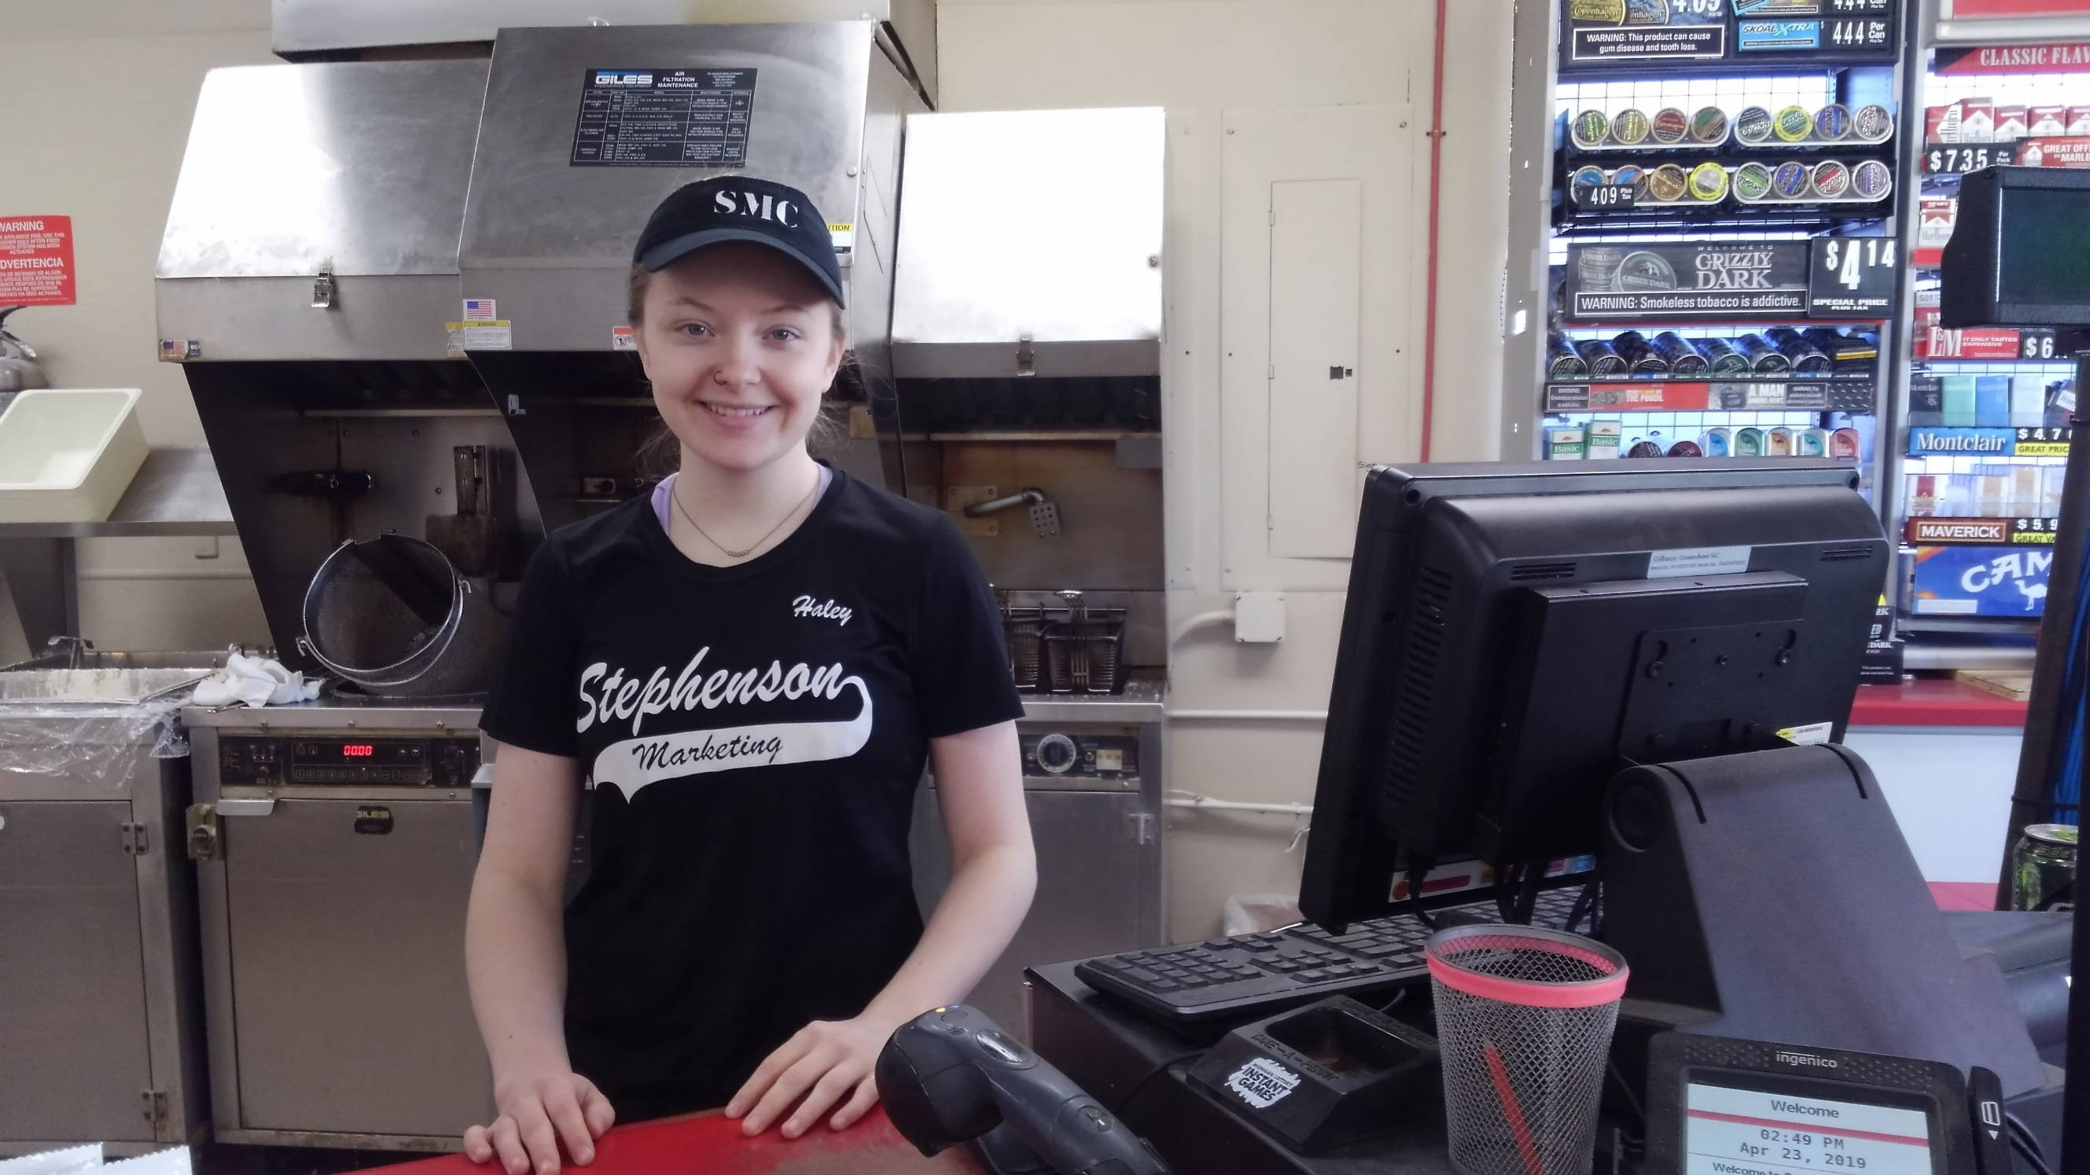
Haley Truitt, C-Store Clerk
Stephenson, MI Location
Haley just celebrated her 3rd year anniversary at the SMC. At the age of 16 she started her first job on April 21st as a stocker and has since moved up to the position of clerk.
She was born and raised in Stephenson. Is a graduate of Stephenson High School. While is school she was on the volleyball, basketball, track and softball team.
Her favorite time of the year is the fall. During that time, she gets to do what she loves most, Hunt.
Family is also very important to her. She loves the Christmas holiday because it the one time the entire family all comes together and is in the same place at the same time.
Her long-term goals are to attend NWTC in Green Bay, WI to pursue a degree in Criminal Justice. Her hopes are to join the Menominee County Sheriff’s Department. When asked why she said “It’s in my blood, my father was in the Air Force and was a MP, her Grandpa, Aunt and Uncle are also police officers and I want to serve the community.”

NEXT ISSUE
- John Erickson, Driver
Stephenson, Feed Mill Location
- Still Time To Get Your Fields Ready

New Summer Apparel

Last spring, we brought in an apparel line. Since then we have increased our inventory. Throughout the year we bring in new items. We have just received our new summer line. Both the Powers and Stephenson c-stores have new designs with great new colors.
This spring we turned our popular Yooper sweatshirt into a t-shirt version. When talking to Stephenson Store Manager, Jen Marciniak she said “adding the t-shirts and sweatshirts have been very popular with the customers. We sometimes have customers come in just to see what new items have arrived”.
With camping right around the corner, stop by and pick up a new sweatshirt. They are a great item to have on a chilly night for around the campfire.
T-shirts start as low as $12.99 and sweatshirts $29.99. So, stop into either of our locations and check out our new lineup. If you need a specific size please let us know and we will be happy to help.
Powers and Stephenson C-Store Hours:
Mon-Sat 5am – 10pm, Sunday 6am – 9pm

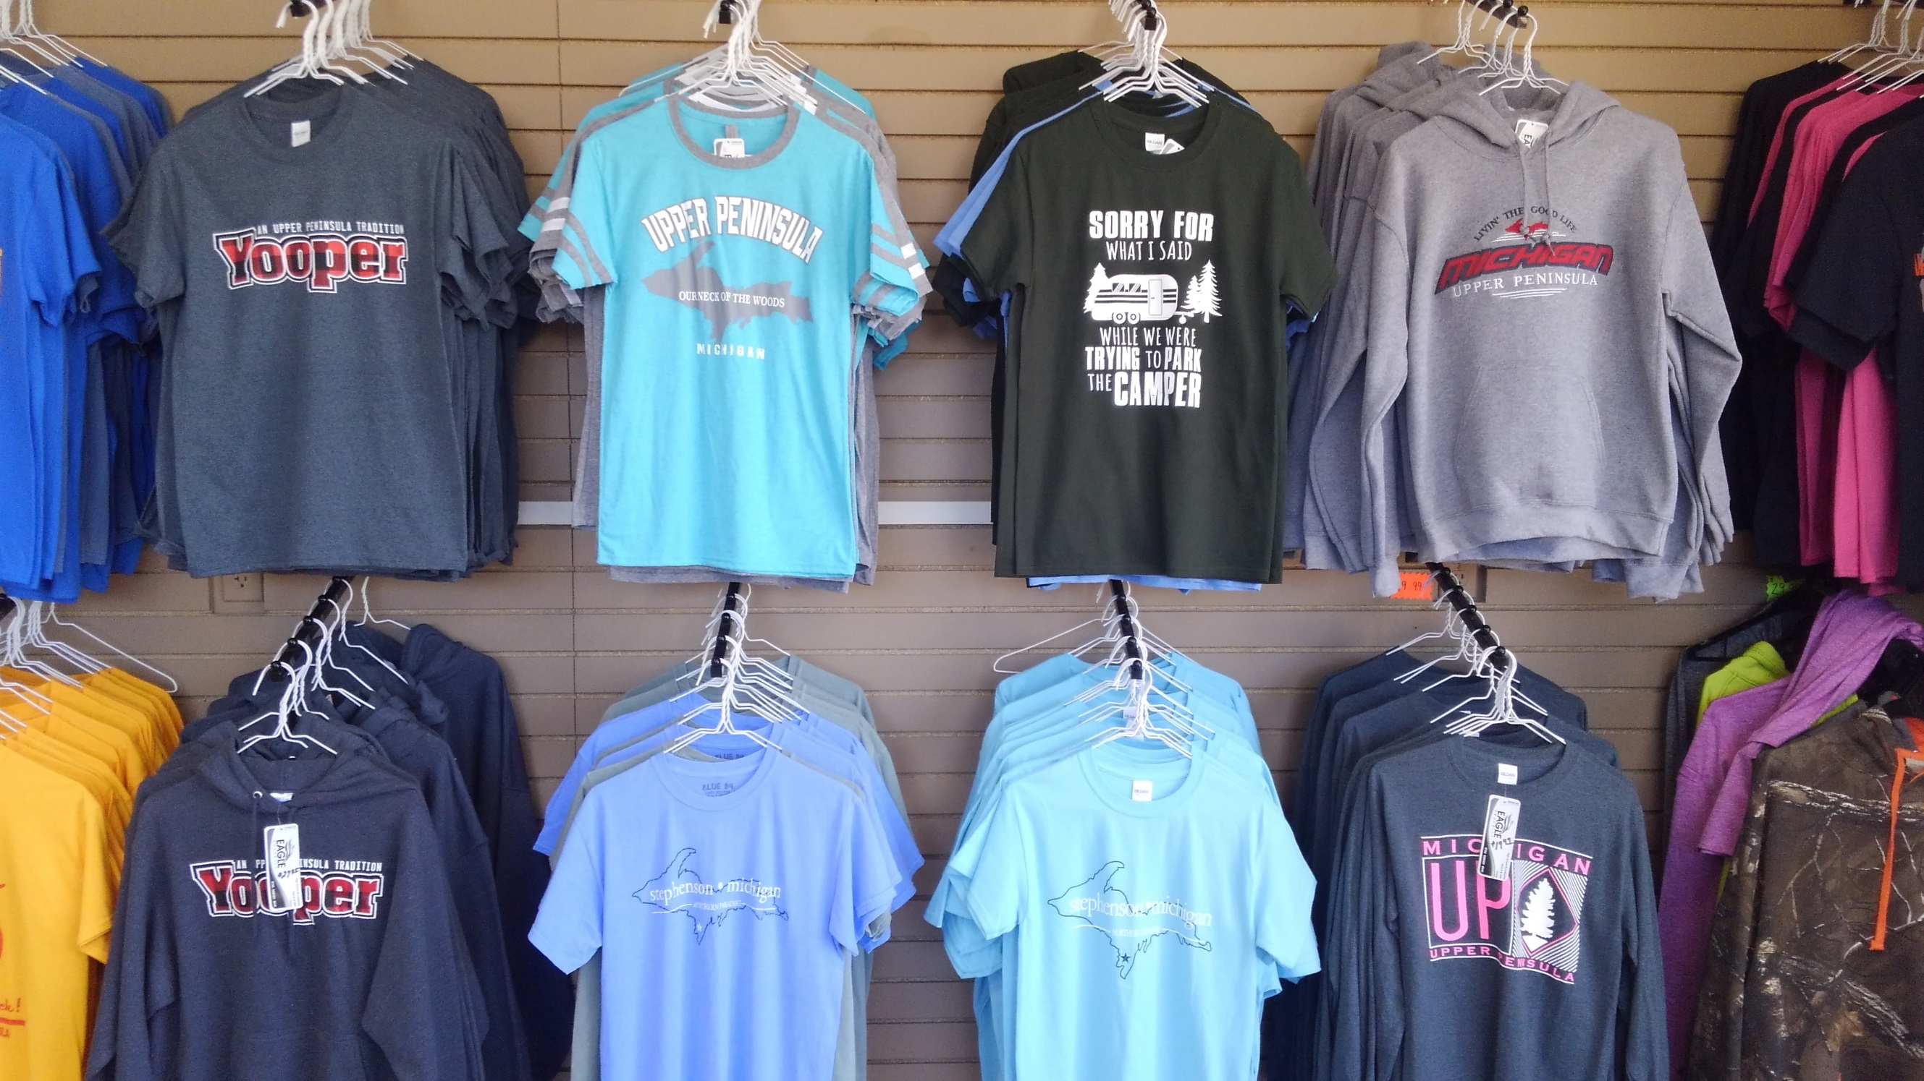

‘

$2.00 OFF
Sweatshirts and T-Shirts
$2.00 off any regular priced
sweatshirt or t-shirt with this coupon.

Valid at: Powers and Stephenson C-Store Locations
EXPIRES: July 31, 2019 (One Per Customer)

