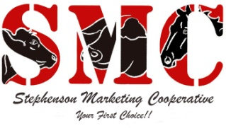
Newsletter
Volume 2, Issue 2 February 2019
EMPLOYEE SPOTLIGHT
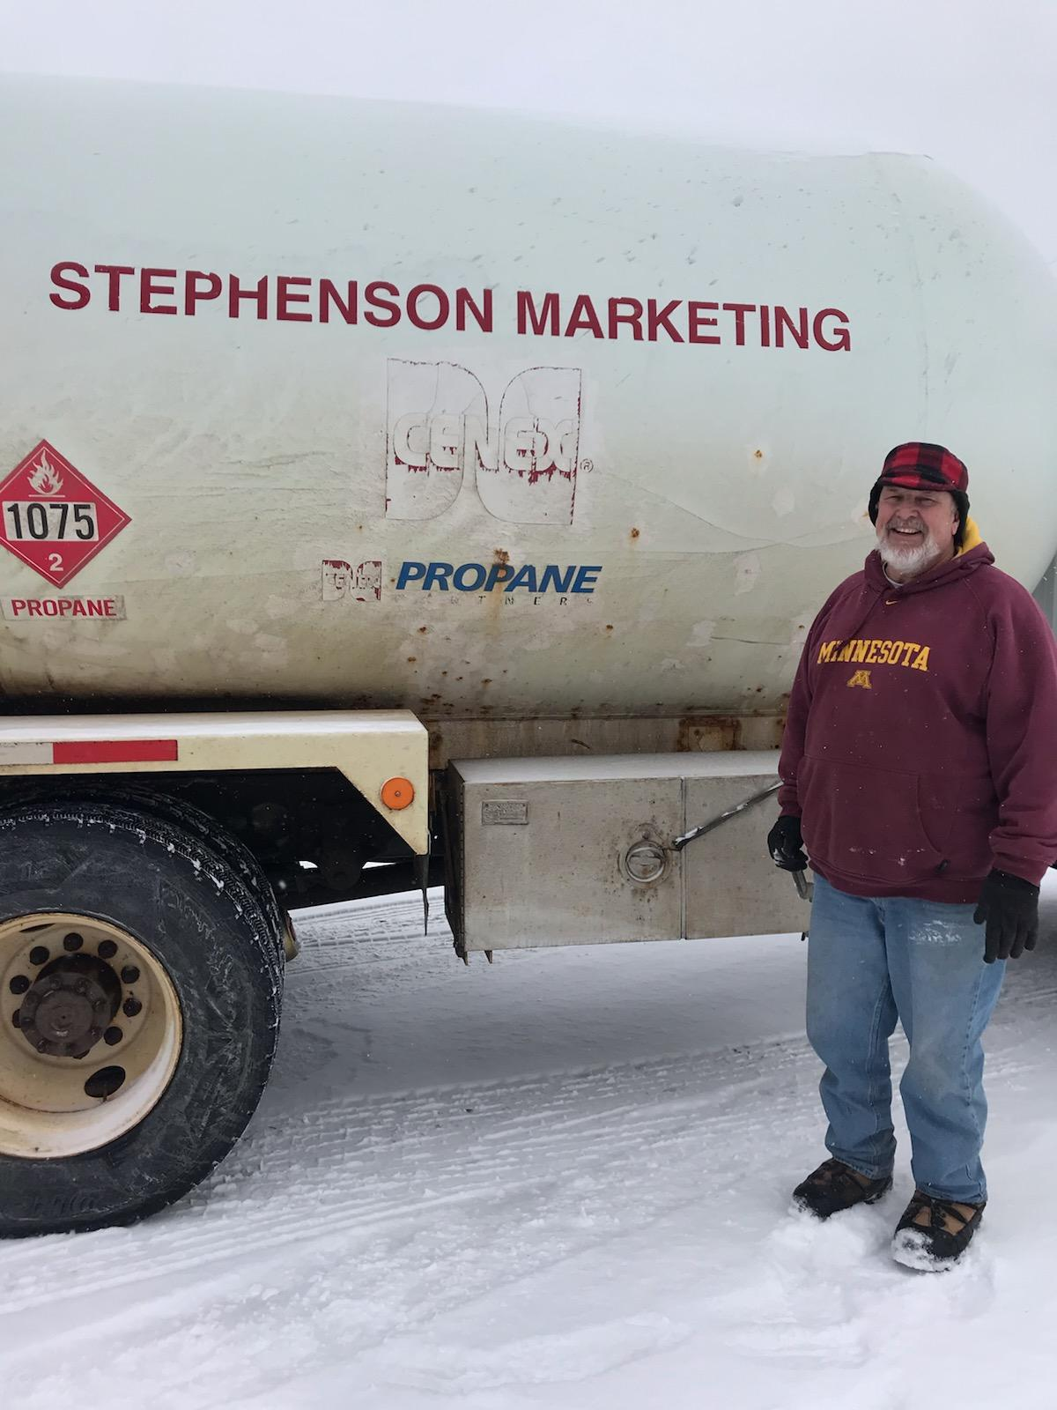
Warren (Bucko) Soderberg, Driver
Florence, WI Location

In the movie Uncle Buck, John Candy’s character is left to care for his Brothers 3 kids. But, in real life Warren (Bucko) comes from a large family of 7 Sisters and 1 Brother. He has a total 90 Nieces and Nephews!! Yes, that correct. He is Uncle to 23, Great Uncle to 27 and Great Great Uncle to 40. He’s also Dad to 9 year old Lilly.
Born and raised in Florence, WI he loves the outdoors. Hunting and fishing has become a large part of what he loves. A dream vacation would have a little cabin at the bottom of a mountain with a fishing stream.
In 1980 he joined the Air Force and stayed active for 8 years. While in the service he played Rugby. During that time he was approached to join a Professional Rugby Team. However, his Colonel said he was too valuable to the service and would not release him.
During the holiday season, Buck has been Santa Clause for the past 38 years in Florence. This year he will be celebrating 10 years at SMC. We thank you for your dedication to SMC and for your service.

- Casey Wilson, Stephenson Feed Mill
- Is your horse area ready for Spring?

Think Spring!

On March 20th Spring will be on the calendar but in the Midwest it may take a little longer. With Michigan and Wisconsin having some of the coldest temperatures in history it hard to believe that Spring is right around the corner.
Soon our staff with be stocking the shelves with lighter fluid, charcoal, camp fuel, lanters and propane refill tanks. With Spring comes camping season and SMC will be ready.
We also carry table fans, box fans, bird feeders, bird seed and potting soil. We even have decorative garden stepping stones in a variety of colors and styles.
Our fishing line is also up at our Stephenson c-store and we are adding new items monthly. Plus our live bait in the store will be fully stock soon in the coming months.
Our Summer beers will also be stocked soon. So stay warm and do the countdown. Think Spring!
Aurora Feed Mill: Mon-Fri 8:30am–5pm, Sat 8:30-Noon
Stephenson Feed Mill: Mon-Fri 8am–4:30pm, Sat 8am-Noon
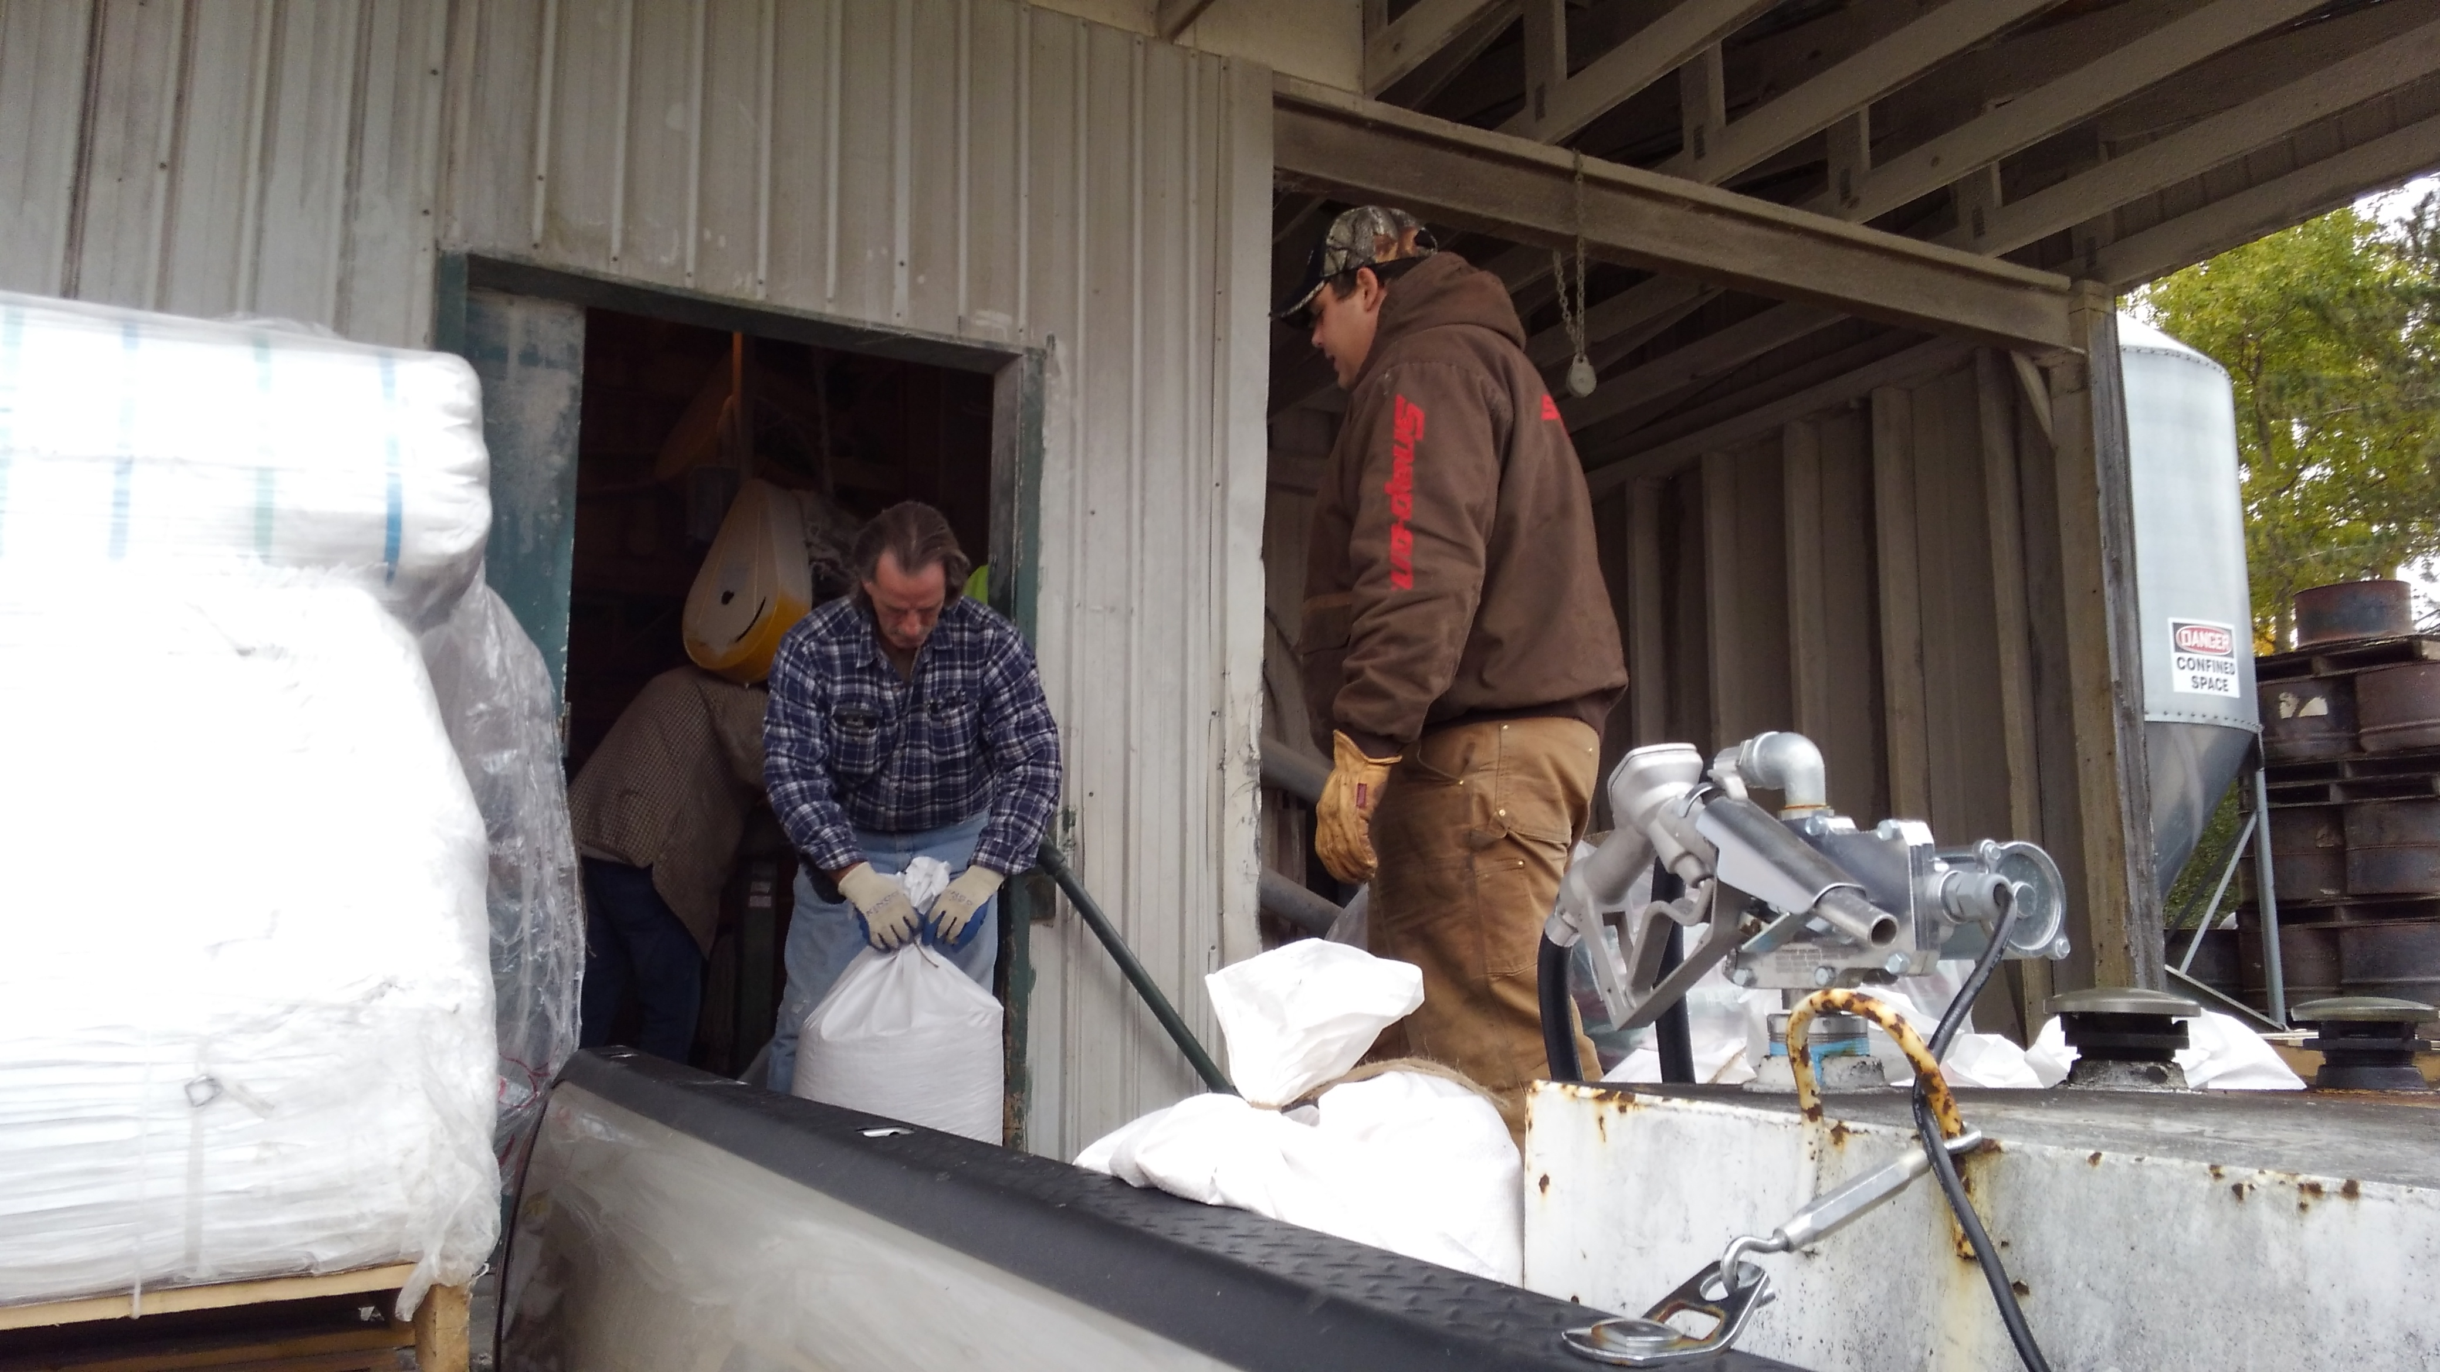

$1.00 OFF

Buy 2 bags of #20 Wild Bird Seed and get $1.00 OFF

Valid at: Stephenson, MI and Aurora, WI Feed Mills
EXPIRES: May 31, 2019 (One Per Customer)

